# Tile : To change the background color

Aim :

To change the background color for any application

Procedure :

• **Create a Sitemap**:

* Home: Daily specials, featured items.
* Menu: Categorized menu items.
* Order: Pre-ordering functionality (if applicable).
* Profile: User preferences and history.
* Feedback: Collect user reviews.

• **Wireframes**: Sketch low-fidelity layouts for each screen. Figma or similar tools are helpful for this step.

1. **Choose a Theme**: Use appealing colors and imagery that reflect the canteen's brand.
2. **Create Visuals**:
   * High-quality images for food items.
   * Easy-to-read fonts and layouts.
3. **Prototyping**:
   * Use tools like Figma to create clickable prototypes.
   * Experiment with interactive elements (buttons, animations).

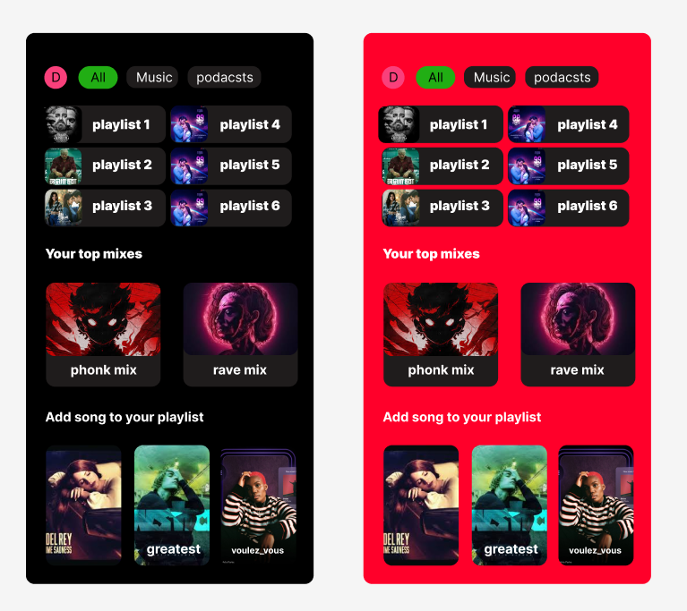

Result :

Changing the background color for the given application